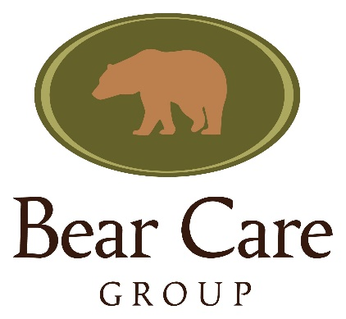

Else Poulsen Memorial Grant

Grant
The Bear Care Group will provide selected recipients with:
- Free conference/workshop registration.
- Financial assistance with travel and accommodation for the conference/workshop.
- Total annual grant amount is $2500 which may be divided between successful applicants to cover costs associated with attendance.

Criteria for Selection
Grants will be awarded based on the following criteria:
- Those working with bears under human care (i.e. In zoos, sanctuaries, rehabilitation facilities, etc.)
- Those wanting to enhance their bear husbandry skills or programs
- Those facing financial barriers to updating their husbandry programs or attending ABC conferences and workshops (those from low- and middle-income countries will have priority)
- Those most likely to be able to apply what they have learned
- Those who have not previously received this grant

The most suitable person(s)/facility will be chosen based on the above criteria and application review. Local applicants will have priority for regional workshops.

Successful candidates must agree to provide the following:
- A written report of how they applied what they learned or present at a future conference/workshop through lecture or poster presentation
- Provide an impact statement (statement for publication on our website and/or Facebook page).

Submission deadlines will be announced before each ABC Conference or Workshop.

Application for Else Poulsen Memorial Grant

Applicant Name Click or tap here to enter text. Email Click or tap here to enter text.

Address Click or tap here to enter text. Phone Click or tap here to enter text.
Click or tap here to enter text.

Organization Name Click or tap here to enter text.

Position/Job Title Click or tap here to enter text. Paid ☐ or Volunteer ☐

Length of time working at current facility/organization (in years) Click or tap here to enter text.

Length of time working with bears and/or other animals (in years) Click or tap here to enter text.

Does your supervisor/employer support you attending the conference/workshop? Yes ☐ No ☐
*Please include a brief letter of support from your supervisor/employer

Tell us a bit about your bears (species, number, age, sex, programs, enclosures, etc.)

What are your learning objectives for the conference/workshop?

What specific goals do you wish to achieve at your facility or with your bears after attending the conference/workshop?

In order to qualify for the grant successful applicants must agree to a follow up with the Bear Care Group to help us measure the success of our program.
Do you agree to a follow up by 1) writing a report of what you learned and how you applied what you learned at the conference/workshop? Or 2) presenting this information at a future conference/workshop either through a poster or a talk? AND 3) writing an impact statement to be published on the BCG website and Facebook page? Yes ☐ No ☐

Have you ever attended an Advancing Bear Care conference or workshop? Yes ☐ No ☐

Have you ever attended another bear husbandry workshop before? Yes ☐ No ☐

